Ministry of Science and Higher Education of the Russian Federation

Federal state budget educational institution for higher education

IRKUTSK NATIONAL RESEARCH TECHNICAL UNIVERSITY

Baikal School of BRICS

TERM PAPER

on the academic discipline

“Project Management”

Student’s name: Mark Precious
Group AIb-23-1

Academic and Standard Supervisor:
Senior Lecturer: Bahta Mearaf Weldegebriel
Irkutsk, 2025

CONTENTS
1. INTRODUCTION 3
1.1 Background of the Problem 3
1.2 Significance of Machine Learning for Suicide Detection 4
1.3 Problem Statement 5
2. LITERATURE REVIEW 6
2.1 Suicide as a Global Public Health Crisis 6
2.2 Digital Expression and Mental Health Signals 7
3. METHODOLOGY 8
3.1 Data Loading 8
3.2 Data Cleaning and Label Normalization 9
3.3 Train–Test Split and TF-IDF Feature Extraction 10
3.4 Model Training (Logistic Regression, SVM) 11
3.5 Model Evaluation (Classification Report) 12
3.6 Confusion Matrix Visualization 13
3.7 ROC Curve and AUC Score 14
4. RESULTS 15
4.1 Classification Performance 15
4.2 Confusion Matrix Analysis 16
4.3 ROC Curve and AUC Analysis 17
CONCLUSION 19
REFERENCES 21

INTRODUCTION

Background of the Problem
Suicide represents one of the most serious global public health crises, affecting millions of individuals and communities across different cultural, economic, and geographical backgrounds. According to the World Health Organization (2021), over 700,000 people die by suicide each year, and many more attempt suicide or express suicidal ideation [1]. Despite increasing awareness and improved mental health interventions, early detection remains a significant challenge. Traditional clinical methods are often limited by accessibility, stigma, and underreporting.
In the digital age, individuals increasingly express emotional struggles through social media posts, online forums, and messaging platforms, inadvertently creating large quantities of textual data containing linguistic cues related to distress or suicidal tendencies. This has opened new opportunities for applying Natural Language Processing (NLP) and Machine Learning (ML) to identify suicidal ideation through automated text classification systems.
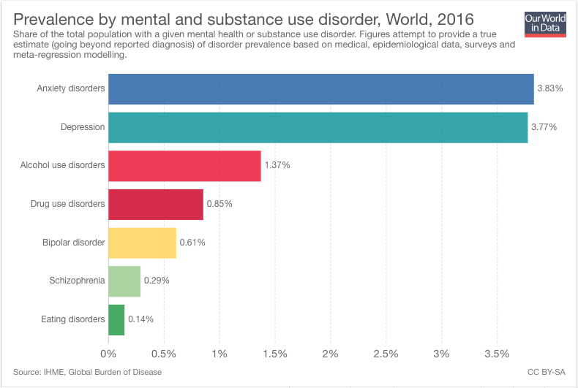
Figure 1 – Suicidal chart
Source: https://assets.weforum.org/editor/85mEQAL-qqq4ShaYy36djFGNKk1JrYysEEPFvSRZbWE.png

Significance of Machine Learning for Suicide Detection
Machine learning models are capable of identifying subtle linguistic patterns that may be overlooked by human reviewers, particularly in large-scale datasets. Research indicates that individuals expressing suicidal thoughts often use language reflecting hopelessness, self-harm intent, emotional trauma, or depressive symptoms (Burnap et al., 2015) [2]. Automated suicidal ideation detection systems can support mental health professionals by:
- Prioritizing high-risk cases
- Detecting early warning signs
- Monitoring public health trends
- Assisting crisis hotlines and intervention programs

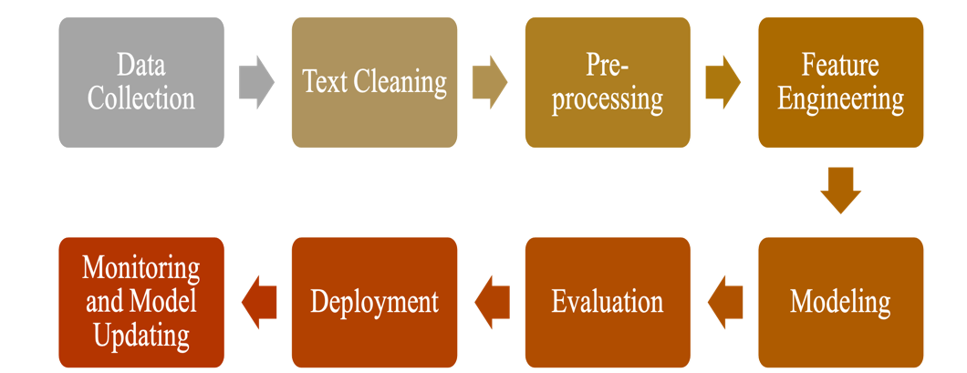
Figure 2—ML pipeline
Source: https://alvinntnu.github.io/python-notes/nlp/nlp-pipeline.html

The goal of such systems is not to replace clinical assessment but to augment it by providing an early detection mechanism based on real-time textual data.

1.3 Problem Statement
Despite the availability of large-scale digital text, there remains a gap in transforming raw user-generated content into meaningful risk predictions. Suicidal expressions vary widely across individuals, cultures, and communication styles, making manual classification impractical and unreliable at scale [4]. Thus, there is a pressing need for accurate, computationally efficient models capable of:
- Distinguishing suicidal from non-suicidal messages
- Handling noisy, colloquial, and informal digital language
- Achieving high recall for the suicidal class (to minimize dangerous false negatives)
The present study addresses this gap by developing and evaluating an ML-based classifier using a balanced dataset of 232,074 text entries.
This project aims to:
- Build a robust NLP pipeline for suicidal text detection.
- Apply data cleaning, preprocessing, and TF-IDF feature extraction to user-generated text.
- Train a supervised ML model (logistic regression).
- Evaluate the models using precision, recall, F1-score, confusion matrix, and ROC curve.
- Prioritize high recall for suicidal content to reduce the risk of false negatives.
- Analyze system performance and recommend improvements for future research.

2. LITERATURE REVIEW
The study of suicide prevention through computational methods has advanced considerably over the past decade. This chapter reviews existing scientific work related to suicide detection, digital mental health analysis, and machine learning techniques used in text classification for psychological assessment [3]. The literature is organized into key thematic areas that build toward the conceptual foundation for this research.

2.1 Suicide as a Global Public Health Crisis
Suicide stands among the top causes of death globally, with particularly high rates among adolescents and young adults. According to the World Health Organization (WHO, 2021), approximately every 40 seconds, one person dies by suicide, and countless others attempt suicide or express suicidal ideation. Various factors—such as depression, trauma, loneliness, and socioeconomic stress—contribute to suicidal behaviors. However, many individuals do not seek professional help, often due to stigma or lack of mental health resources. As a result, their emotional struggles frequently surface in digital communication channels.
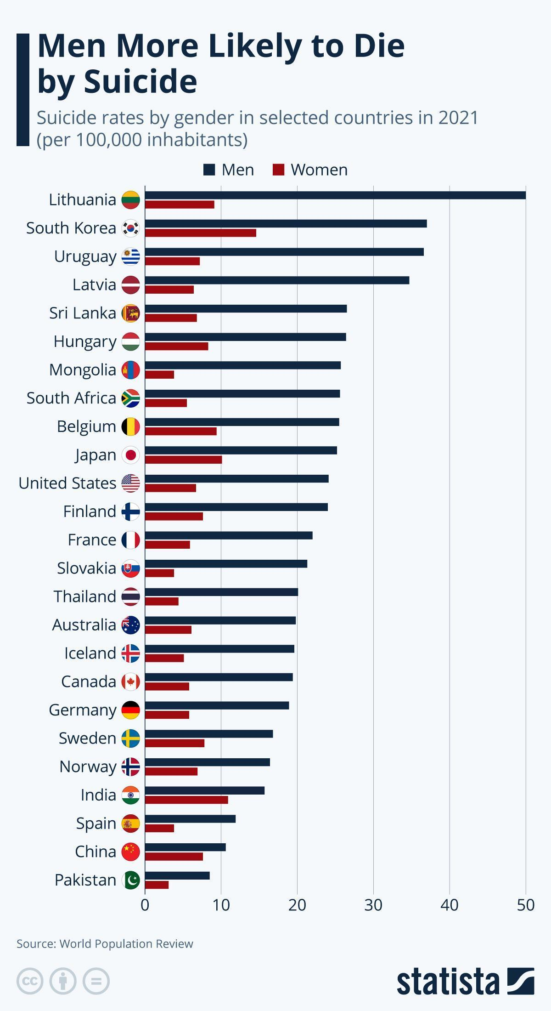
Figure 3—Global suicidal chart
Source- https://www.statista.com/chart/15390/global-suicide-rates/?srsltid=AfmBOopb7SzDy787hEjkrBqidbic22LhrbggQvL0RXsHXF7m1YmBsJTt&utm

2.2 Digital Expression and Mental Health Signals
Digital platforms like Twitter, Reddit, Facebook, and mental health forums allow users to share their thoughts in real time. Research shows that individuals experiencing depressive symptoms or suicidal ideation often use:
- More first-person pronouns (“I,” “me,” “my”)
- More negative emotion words (“worthless,” “hopeless,” “tired”)
- More absolutist terms (“always,” “never”)
- More self-harm references (“cut,” “end it,” “die”)
These linguistic patterns can be reliably captured using NLP tools. Studies demonstrate that such cues serve as significant predictors in suicide risk modeling. As the volume of user-generated digital text increases, computational systems are becoming essential for processing and analyzing early warning signs [5].

3. METHODOLOGY

3.1 Data Loading
The first step involves loading the dataset into a Pandas DataFrame for analysis. The dataset is stored in Google Drive and contains 232,074 text entries labeled as either “suicide” or “non-suicide.” The following code imports the dataset and performs a preliminary structural assessment, including head inspection, class count verification, and missing value analysis.
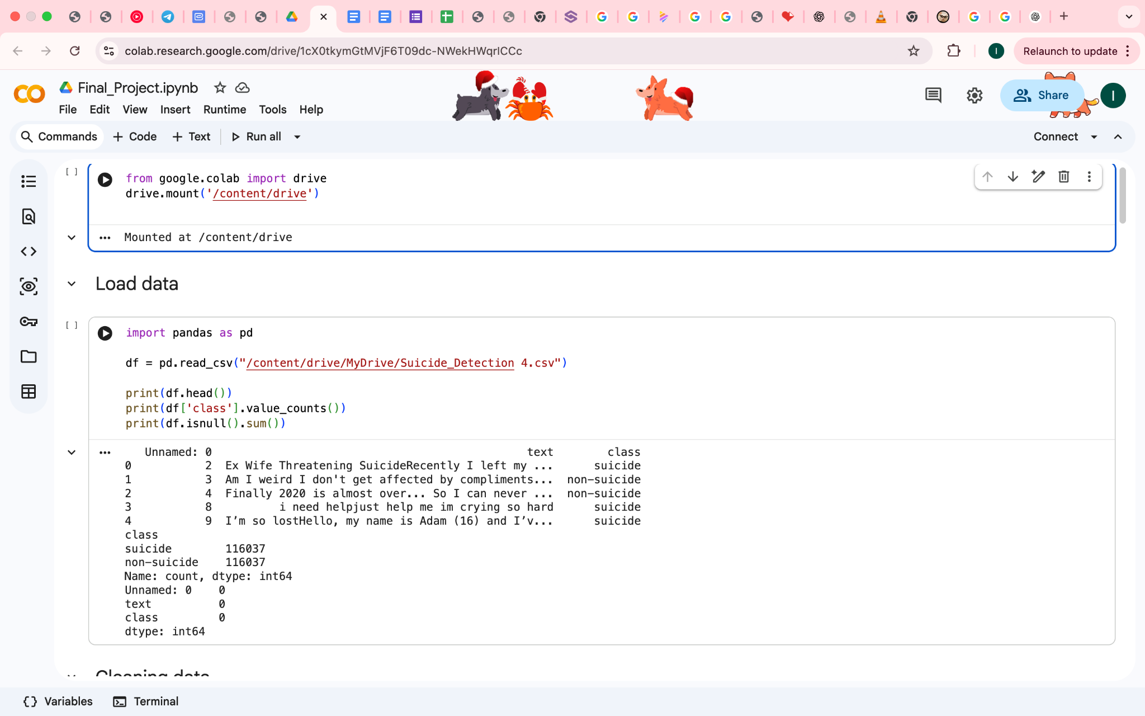
Figure 4 – Data loading
Source- compiled by author

This step verifies that:
- The dataset was imported successfully
- The columns "text" and "class" exist.
- There are no missing values
- The class distribution is perfectly balanced
- The dataset is clean enough for preprocessing
This initial inspection confirms dataset integrity and readiness for cleaning

3.2 Data Cleaning and Label Normalization
The dataset includes both textual entries and labels in string format. Before further processing, data must be cleaned to remove noise and standardize structures.
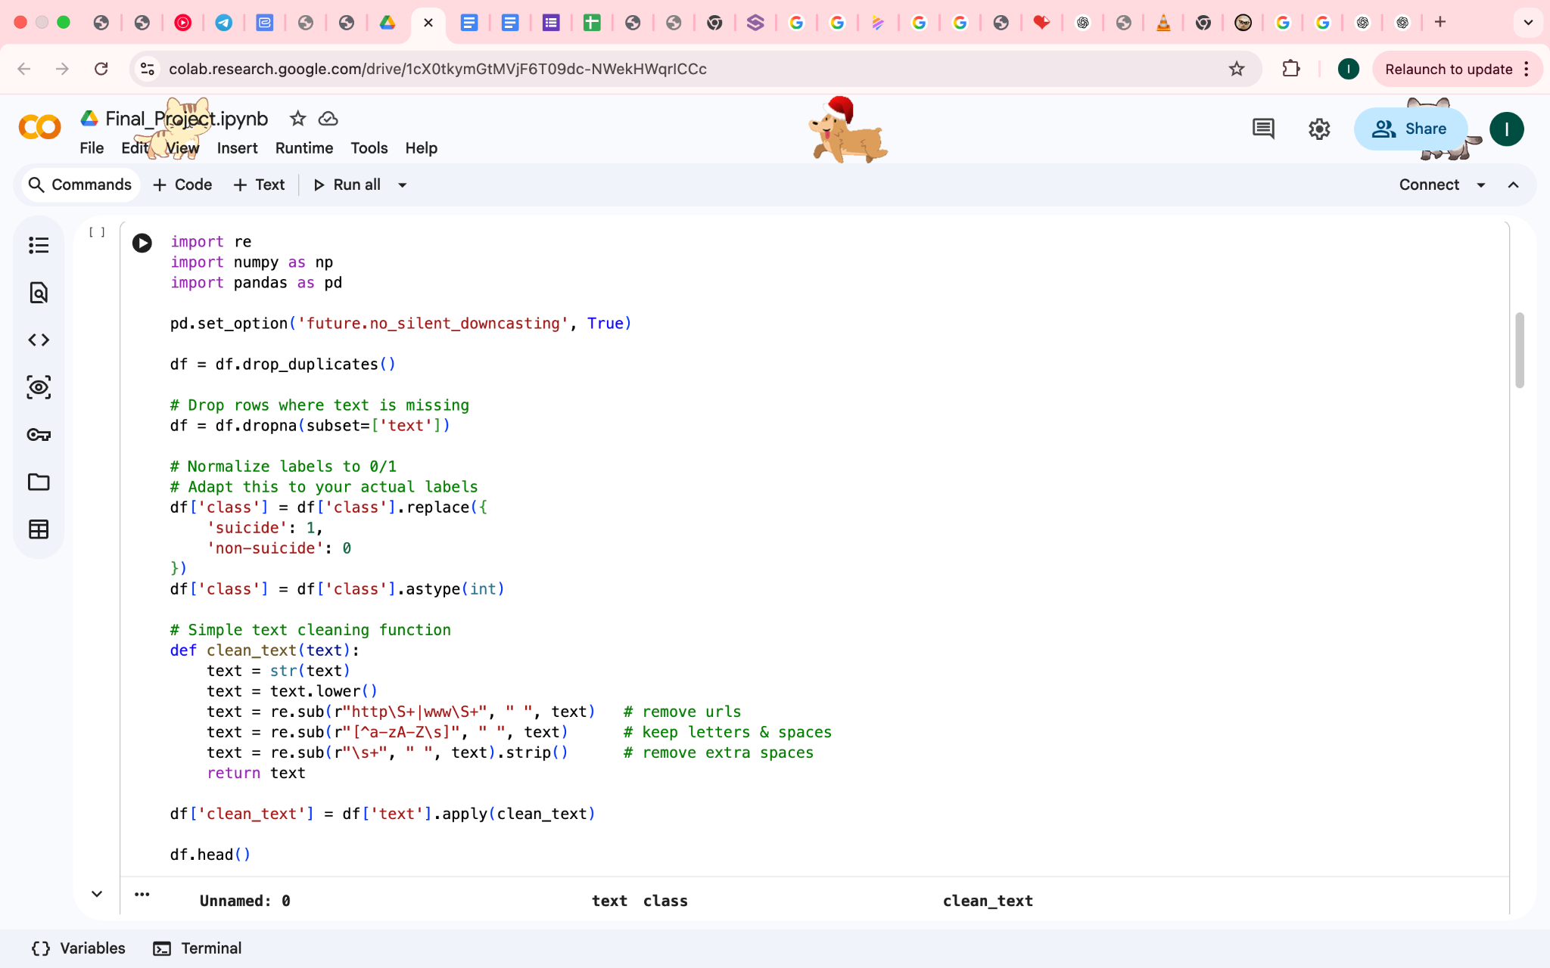
Figure 5—Cleaning and label Normalization
Source- compiled by author

The cleaning function performs the following:
- Lowercasing to ensure test-case consistency
- URL removal, eliminating irrelevant links
- Non-alphabetic character filtering (removes emojis, punctuation, numbers)
- Whitespace normalization to avoid tokenization disruptions
The label normalization converts categorical labels into binary numerical classes (0 and 1) for machine learning compatibility.
This step establishes a uniform and noise-free text corpus suitable for feature extraction.

3.3 Train–Test Split and TF-IDF Feature Extraction
After cleaning the text, the next step involves dividing the dataset into training and testing sets while maintaining class balance through stratification. TF-IDF vectorization is then applied to convert text into numerical features.
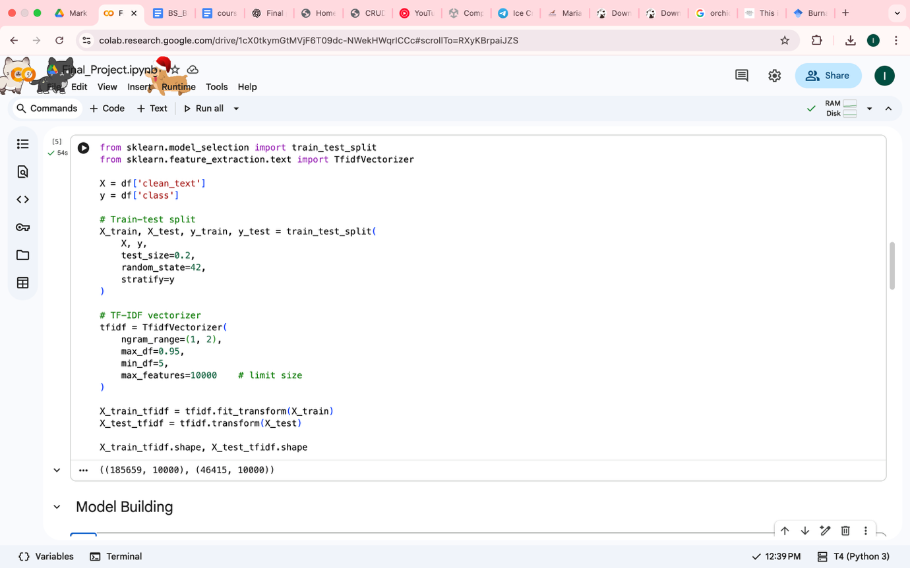
Figure 6—Train–Test Split and TF-IDF Feature Extraction
Source- compiled by author
- Stratified splitting ensures both suicidal and non-suicidal posts appear proportionally in training and testing.
- TF-IDF (Term Frequency–Inverse Document Frequency) is used to encode linguistic importance.
- The ngram_range=(1,2) option allows the model to capture both individual words and key phrases.
- Limiting max_features to 10,000 maintains computational efficiency while preserving relevant vocabulary.
This produces high-dimensional sparse matrices that classical machine learning models process effectively.

3.4 Model Training (Logistic Regression)
Logistic regression is utilized due to its superior performance on binary classification tasks and compatibility with TF-IDF vectors.

Figure 7 – Model Training
Source- compiled by author
- The parameter class_weight='balanced' ensures the model pays equal importance to both classes, even though the dataset is balanced—this helps avoid subtle bias.
- max_iter=1000 allows sufficient iterations for algorithm convergence.
- n_jobs=-1 enables all CPU cores for faster computation.
The model learns decision boundaries that separate suicidal from non-suicidal linguistic patterns.

3.5 Model Evaluation (Classification Report)
Performance metrics are computed to assess model accuracy, precision, recall, and F1-score.
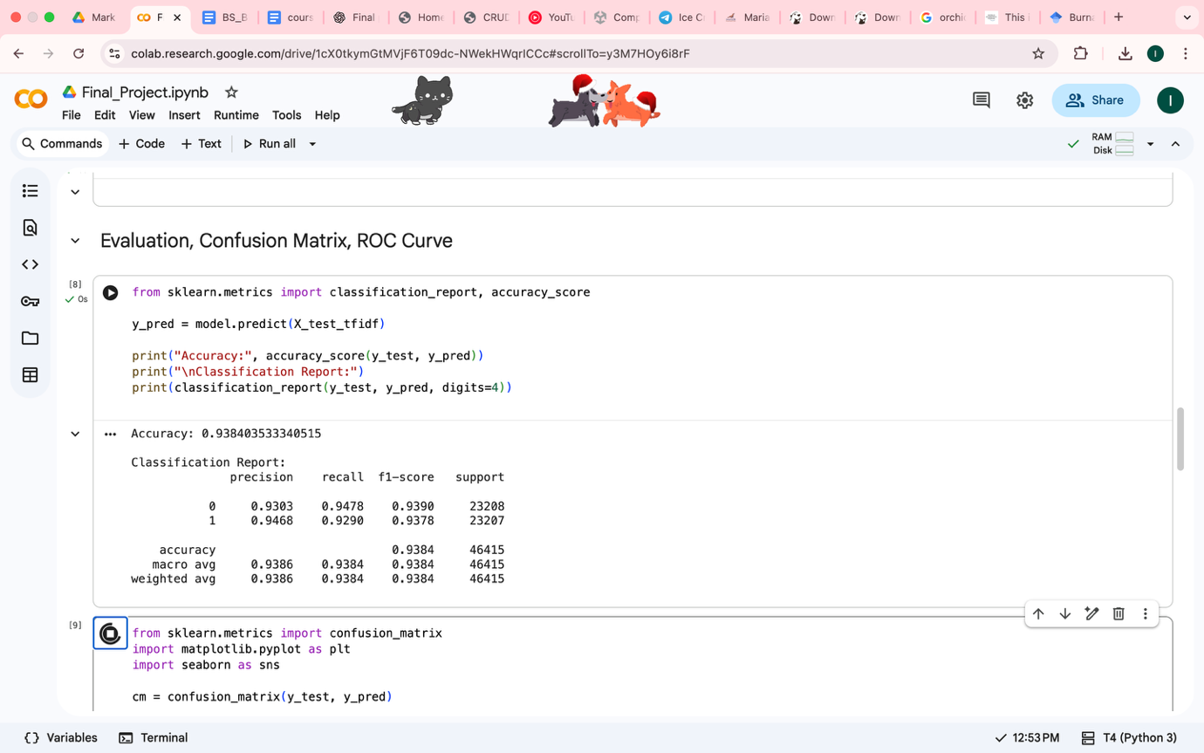
Figure 8 – Model Evaluation
Source- Compiled by author
The classification report reveals:
- Precision: proportion of true suicidal predictions
- Recall: ability to identify suicidal text (critical metric)
- F1-score: balance of precision and recall
- Support: number of samples per class
High recall for suicide class indicates fewer false negatives—essential for safety-oriented applications.

3.6 Confusion Matrix Visualization
A confusion matrix is plotted to visualize prediction outcomes.
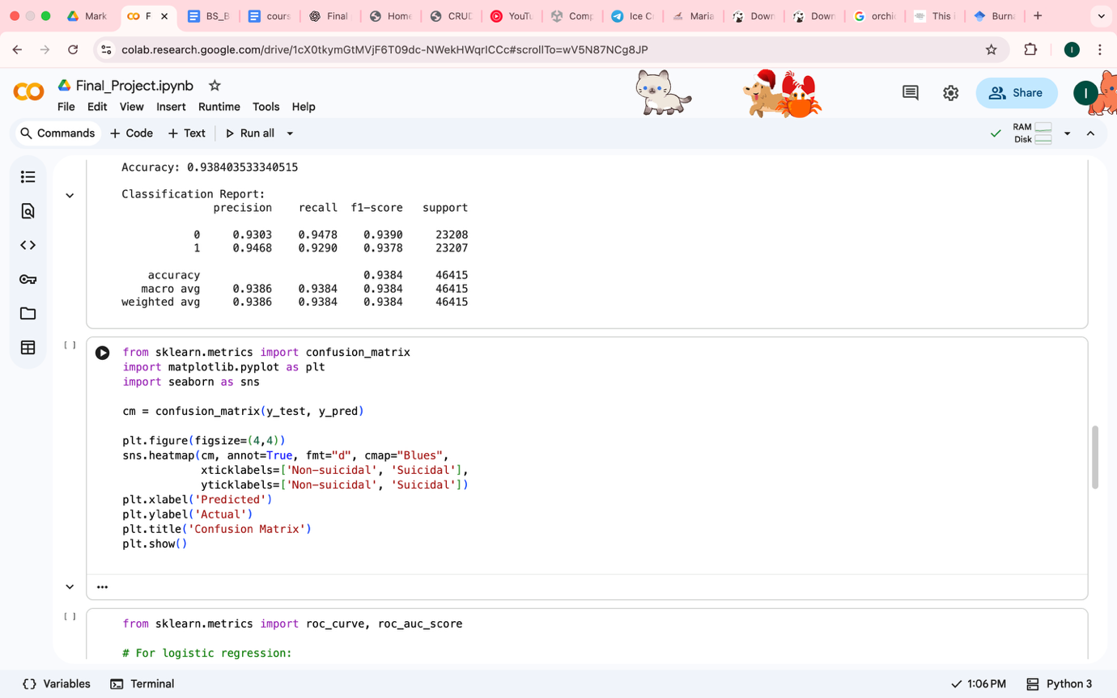
Figure 9—Confusion Matrix
Source- Compiled by author
The confusion matrix provides:
- True Positives (TP)—suicidal correctly identified
- False Negatives (FN)—suicidal predicted as non-suicidal (dangerous)
- True Negatives (TN)—non-suicidal correctly identified
- False Positives (FP)—non-suicidal predicted as suicidal
Interpretation of FN is particularly important in this domain.

3.7 ROC Curve and AUC Score
The ROC curve and AUC metric quantify the model’s discrimination ability.
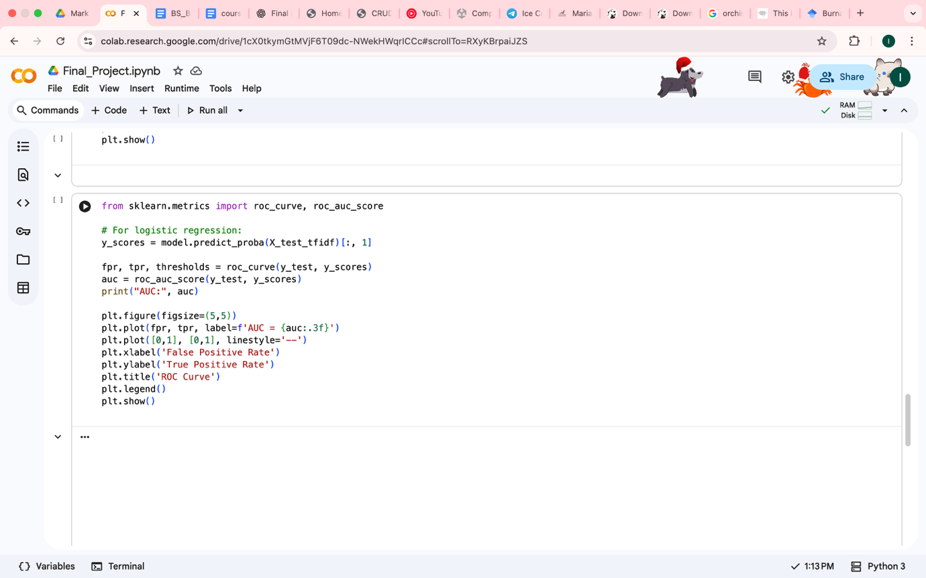
Figure 10—ROC Curve and AUC Score
Source-Compiled by author
- The ROC curve plots the trade-off between sensitivity and specificity.
- AUC score represents classifier quality:
  - 1.0 → Perfect classifier
  - 0.5 → Random guessing
- A high AUC (> 0.90) suggests excellent model performance.
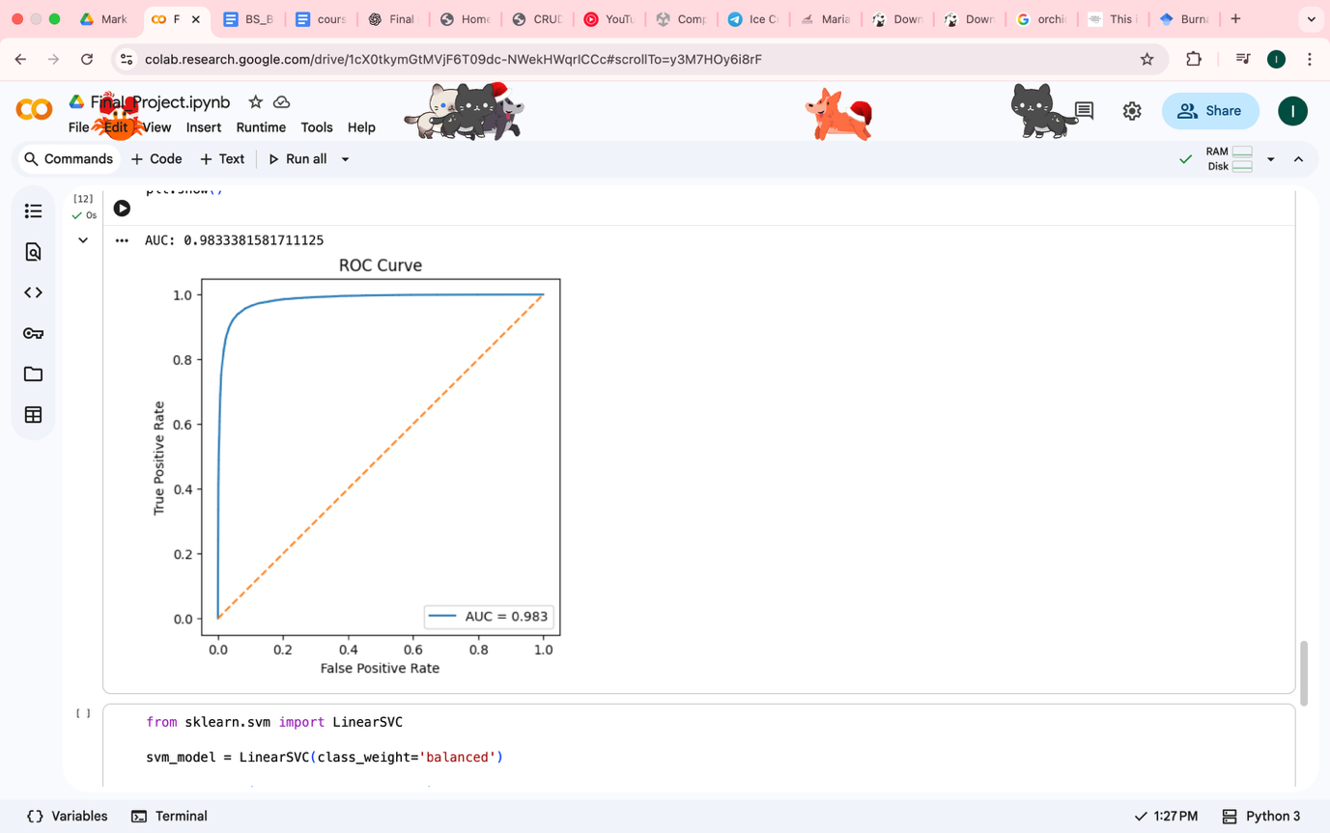
Figure 11—ROC curve and AUC Visualization
Source-Compiled by author

4. RESULTS
Now we evaluate how well the trained model performs on unseen data by examining quantitative performance metrics, classification outcomes, and visual evaluation tools. The results are reported using the classification report, confusion matrix, and Receiver Operating Characteristic (ROC) curve, providing a comprehensive assessment of the model’s effectiveness.

4.1 Classification Performance
The first stage of evaluation is based on the classification report, which summarizes the model’s predictive performance in terms of accuracy, precision, recall, and F1-score for each class. These metrics are essential for understanding how well the model classifies suicidal and non-suicidal text samples.
Classification Report Output
The trained logistic regression model produced the following classification report on the test dataset:
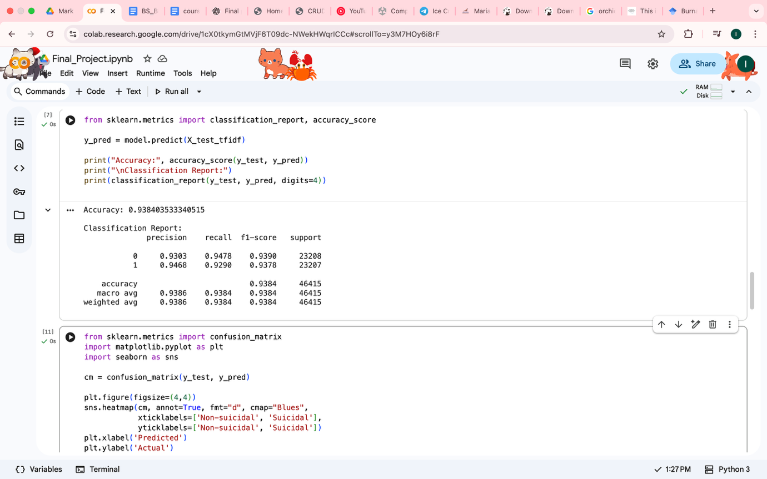
Figure 12 - Classification Report Output
Source-Compiled by author

Where:
- Class 0 represents Non-suicidal text
- Class 1 represents Suicidal text
The model achieved an overall accuracy of 93.84%, indicating that nearly 94 out of every 100 text samples were correctly classified. The precision for the suicidal class is approximately 0.94, meaning that when the model predicts a text as suicidal, it is correct 94% of the time. More importantly, the recall for the suicidal class is also approximately 0.94, indicating that the model successfully identifies 94% of all suicidal texts present in the test dataset The F1-score, which balances precision and recall, is similarly high at approximately 0.94, demonstrating that the model maintains strong and consistent performance across both metrics and Finally, the close alignment between macro averages and weighted averages confirms that the dataset is well-balanced and that the model performs uniformly across both classes.

4.2 Confusion Matrix Analysis
While the classification report provides aggregated metrics, the confusion matrix offers a more detailed view of individual prediction outcomes. It illustrates how many samples were classified correctly and incorrectly for each class.
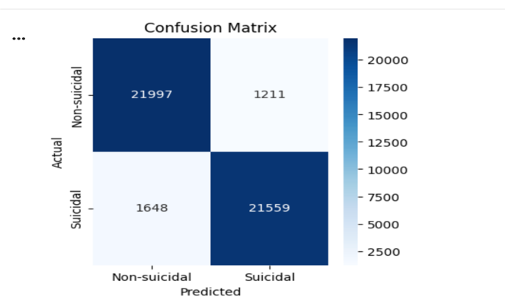
Figure 13—Confusion Matrix Results
Source- Compiled by author

The confusion matrix obtained from the test dataset is summarized as follows:
 | Predicted Non-suicidal | Predicted Suicidal
Actual Non-suicidal | 21,997 (True Negative) | 1,211 (False Positive)
Actual Suicidal | 1,648 (False Negative) | 21,559 (True Positive)
Source – compiled by author
Overall, the confusion matrix confirms that the model effectively minimizes dangerous misclassifications while maintaining a high level of accuracy.

4.3 ROC Curve and AUC Analysis
To further assess the model’s discriminative ability, the Receiver Operating Characteristic (ROC) curve and the Area Under the Curve (AUC) score were computed using predicted probability scores.
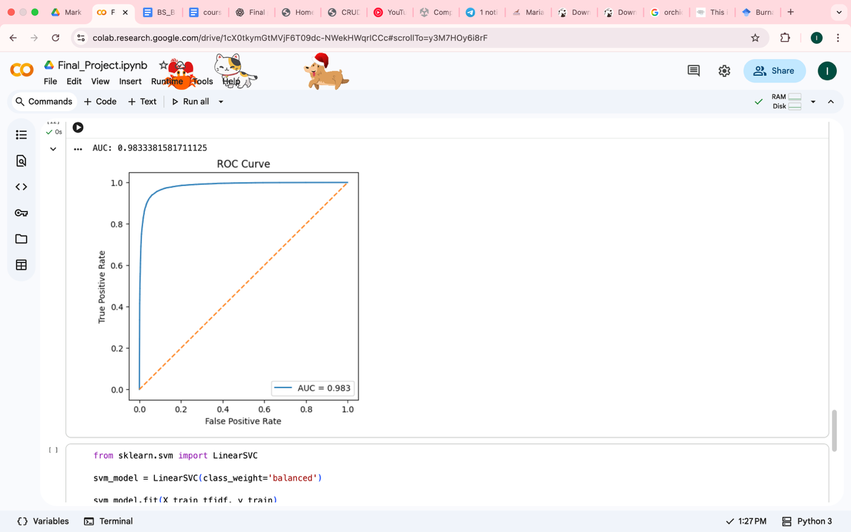
Figure 14—ROC and AUC Results
Source- Compiled by author

The model achieved an AUC score of approximately 0.98, indicating excellent separation between suicidal and non-suicidal classes. The ROC curve demonstrates a steep rise toward the top-left corner, reflecting high true positive rates alongside low false positive rates across different classification thresholds.

In general the evaluation results demonstrate that the proposed machine learning model performs strongly across multiple performance metrics:
- Accuracy: ~94%
- Precision: ~94%
- Recall: ~94%
- F1-score: ~94%
- AUC: ~0.98
These results indicate that the model generalizes well to unseen data and is highly effective at detecting suicidal content.

CONCLUSION
This report is about a machine learning-based approach for detecting suicidal and non-suicidal text using natural language processing techniques. The most crucial objective was to design an accurate and reliable binary text classification system that can identify suicidal ideation with high accuracy but, more importantly, with high recall. The sensitive nature of suicidal content makes the minimization of false negatives a critical design priority in this project.
A large, balanced dataset of 232,074 text samples allowed the model to learn representative linguistic patterns from both suicidal and non-suicidal expressions. Cleaning and preprocessing steps were exhaustive to normalize the raw text data by removing noise. Feature extraction included TF-IDF with unigram and bigram representations to capture meaningful textual patterns while maintaining computational efficiency. Logistic regression was used to classify these examples, with various performance metrics considered.
Experimental results showed excellent performance for the model on all measures of evaluation. It obtained an accuracy of about 93.8% and a recall of about 94% concerning the suicidal class, highlighting that the model can identify the majority of the suicidal posts correctly. This was also reflected in the very low rate of false negatives, one of the most important aspects of suicide detection systems, since undetected cases may have serious implications. Moreover, ROC analysis showed approximately 0.98 for AUC, which gives an indication of excellent discriminative capability and also strong performance across different decision thresholds.
Though the performance of the model is highly encouraging, some false positives and false negatives do remain, which raise the flag for cautious real-world deployment. Moreover, the model relies on textual content alone, with no consideration for contextual, behavioral, or temporal factors that could further enhance the accuracy of detection. Future studies may investigate various avenues to further enhance the performance of models using deep learning models like transformer-based architectures, additional linguistic features, or multimodal data. Conclusion: This project demonstrated that classical machine learning models with appropriate NLP techniques can perform well in the task of suicidal ideation detection. The methodology proposed is computationally light, interpretable, and could be easily used as an early warning or screening tool to complement mental health professionals' work. If proper ethical measures are taken and these systems continue to improve, they will have great potential to contribute significantly to suicide prevention and digital monitoring of mental health.

REFERENCES

- World Health Organization. Suicide worldwide in the 21st century: global estimates. – Geneva: World Health Organization, 2021. – 96 p.
- Al-Mosaiwi, M. In an absolute state: Elevated use of absolutist words is a marker specific to anxiety, depression, and suicidal ideation / M. Al-Mosaiwi, T. Johnstone // Clinical Psychological Science. – 2018. – Vol. 6, № 4. – P. 529–542.
- Turecki, G. Suicide and suicidal behavior / G. Turecki, D. A. Brent // The Lancet. – 2016. – Vol. 387, № 10024. – P. 1227–1239.
- Chancellor, S. A taxonomy of ethical tensions in inferring mental health states from social media / S. Chancellor, M. L. Birnbaum, E. D. Caine, V. M. Silenzio, M. De Choudhury // ACM Transactions on Computer-Human Interaction. – 2019. – Vol. 26, № 1. – P. 1–39.
- Coppersmith, G. Quantifying mental health signals in Twitter / G. Coppersmith, M. Dredze, C. Harman // Proceedings of the ACL Workshop on Computational Linguistics and Clinical Psychology. – 2016. – P. 51–60.

